**COUNTRY PROFILE**

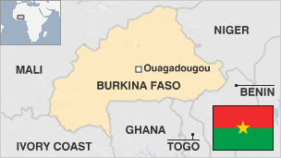

Burkina Faso is a landlocked West African state. With a total border length of 3,192 kilometers (1,984 miles), Burkina Faso is bordered by Mali to the north and west; Niger to the east; and Benin, Togo, Ghana, and Cote d'Ivoire to the south.

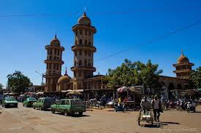

It has a surface area of 274,122 square kilometers (105,839 square miles), making it slightly larger than the U.S. state of Colorado.

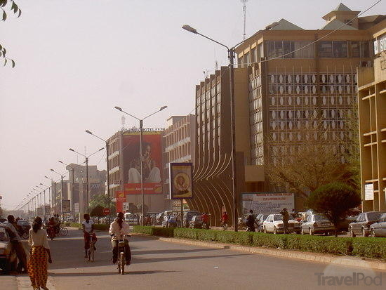

The country spans 400 kilometers (250 miles) from east to west and 200 kilometers (125 miles) from north to south.

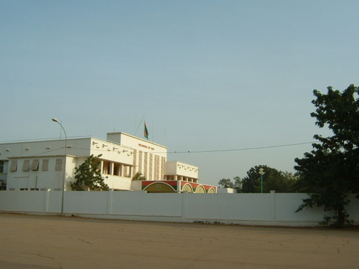

The capital, Ouagadougou, is located in the center of the nation.

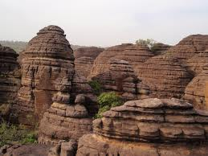

A natural transit hub for West Africa, Burkina’s central location in West Africa positions it as a hub of regional corridors.

